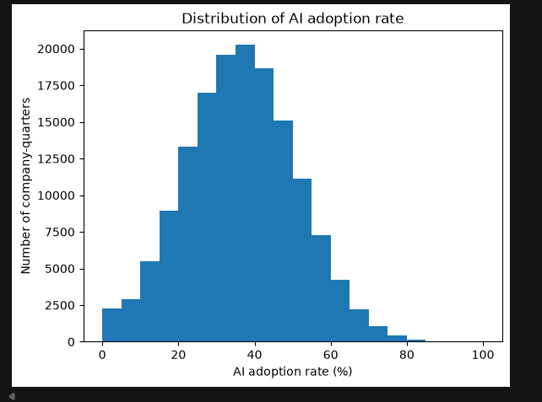
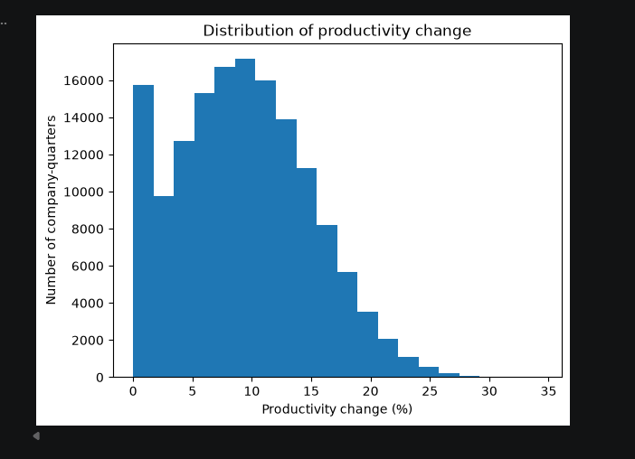
Why a histogram is the appropriate chart here
Both ai_adoption_rate and productivity_change_percent are continuous numeric variables. A histogram is the right tool because it shows the shape of a single continuous variable's distribution —where values cluster, how spread out they are, and whether the distribution is symmetric or skewed. That's something a table of summary stats (mean, min, max) can't show on its own — two datasets can have the same mean and completely different shapes.
What each histogram actually shows
- AI adoption rate: roughly bell-shaped, peaking around 30–40%, tapering off fairly symmetrically toward 0% and 80–90%. This tells you most companies sit in a moderate adoption range — very few have gone "all in" (near 100%) or done nothing at all (near 0%).
- Productivity change: this one is more interesting — it rises to a peak around 8–10%, then tails off to the right toward 30%+ (right-skewed), but there's also a small spike right at 0–2% before a dip. That little notch is worth calling out explicitly in your report as an "unusual pattern" — it could suggest a subgroup of companies (e.g. very low/no adoption) reporting little to no productivity gain, distinct from the main bulk of the sample.
What the rubric wants beyond just the picture (Task 4)
Producing the histogram alone isn't enough — the rubric specifically asks you to:
- Analyse the distribution shape — state explicitly whether each variable is skewed (you already have skew() values from the descriptive-stats cell — quote them).
- Note missingness patterns — you already showed 0 missing values for both; say so here as supporting evidence.
- Flag unusual patterns — that notch near 0–2% productivity change is exactly this ask; don't skip past it.
- Tie it back to usefulness/quality of the data — e.g. "the adoption-rate distribution's moderate spread and lack of extreme skew supports using it as a reliable predictor variable; the productivity-change tail suggests a small number of high-performing outliers worth checking in the outlier-detection step."
That last point is what turns "here's a chart" into the kind of analysis the marker is actually looking for — the histogram is evidence, but the sentence connecting it back to your research question is what earns the marks

